
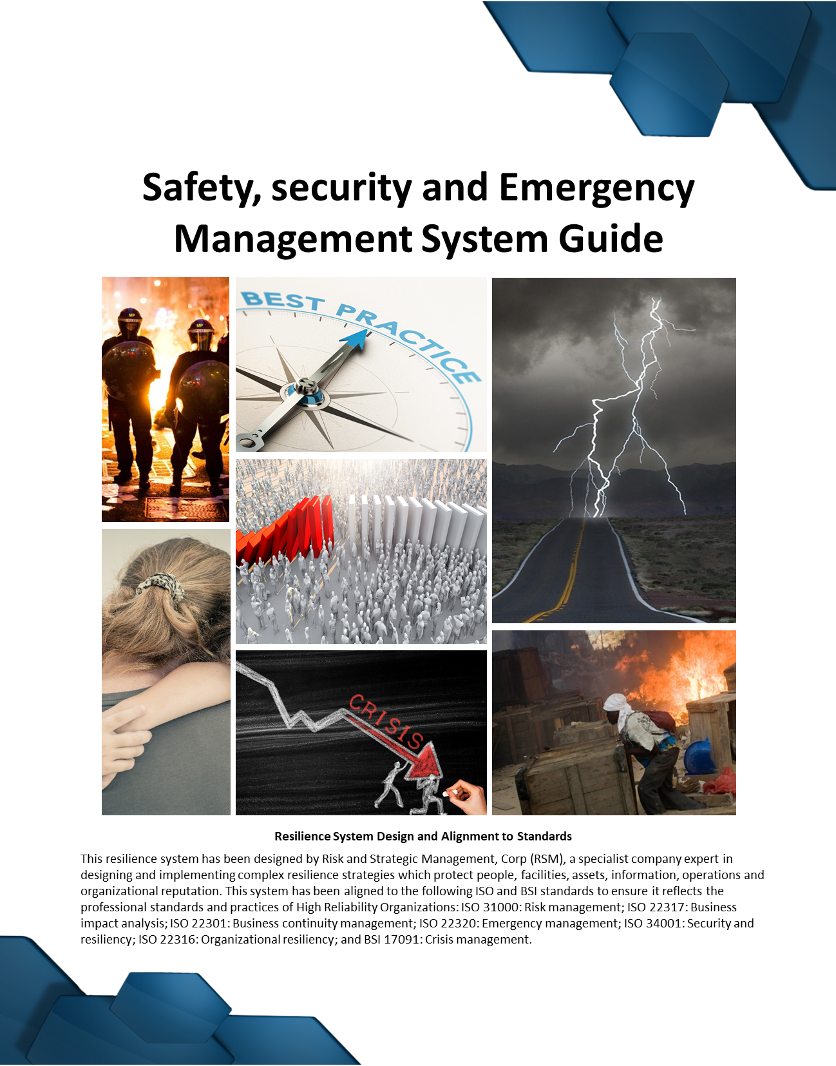

Table of Contents

INTRODUCTION 2
The Safety, Security and Emergency Management Team 3
Completing a Country SSEMP 4
Safety, Security and Emergency Management Team Meetings 4
Decision-Making Authorities 4
Understanding Risk Management 5
The Security Function 6
Risk Event Levels 7
Crisis Communications and Stakeholder Management 8
Safety and Emergency Communications 8
Lost Communications Procedures 9
Safety and Security Reports 10
Security Controls and Minimum Standards 10
Office Safety and Security 11
Travel Risk Management 12
Useful Mapping 15
Branding 15
Information Security and Data Back-Ups 16
Pilfering and Theft 17
Cash Management 17
Medical Management and Suppliers 18
Investigations and Discipline 18
Emergency [Crisis] Preparedness and Response 18
Alert States 20
Trigger Response Plans 21
Threats and Extortion 22
Crisis Response Considerations 22
Hibernation, Relocation and Evacuation Management 25
Data Back-Ups and Protection of Assets and Information 25
Leveraging Resources 25
Emergency Cash and Wage Payments 26
Building Awareness and Competency 26
Training Resources 26
Training Administration 27

Document Register: Managers should reference the Document Register to identify supporting plans, guidelines, protocols, templates and infographics which might be applicable to their requirements.

INTRODUCTION

The Partners of the Americas Safety, Security and Emergency Management Guide is part of a suite of safety and security policies, plans, guidelines, protocols and measures [a system] used to protect our staff, assets, operations, information, organizational interests and reputation on a global basis. This Guide forms the standards and practices expected across all projects, in every country. The Guide also seeks to concurrently protect our donors, funders, and partners from harm. The Guide is designed to support projects in creating the conditions where risk management efforts bring potential humanmade and natural threats to ‘As Low As Reasonably Practical’ or ALARP as part of all ‘All Hazards’ approach to risk.
This Guide is designed to meet a wide spectrum of humanmade threats and natural hazards, defining our standards and practices through effective resilience preparedness planning, creating a clearly understood approach to safety, security and emergency management. The Guide sits within the organizational business and continuity management system and is then operationalized at the country or activity level through the country Safety, Security and Emergency Management Plan and the associated Risk Register and Treatment Plan – both of which then reflect the unique risk conditions, needs and operating practices of a country or activity. The Emergency Action Plan of pre-planned response checklists provide best-practice based set of protocols to address likely humanmade and natural risks, applied in the context of the operating environment.
This system operates within the broader organizational resilience and business continuity management system and leverages a library of useful subordinate plans, guidelines, protocols and infographics.
The goal of the safety, security and emergency management system is to:
Provide a safe and productive operating environment for staff, where risks are identified and either avoided or appropriately mitigated before they occur, and where emergencies and safety and security-related incidents of all kinds are managed in an effective and professional manner.
This Guide and associated Plans are aligned to the following international standards:
      - ISO 31000: Risk management.
- ISO 22317: Business impact analysis.
- ISO 22320: Emergency management.
- ISO 34001: Security and resiliency.
- ISO 22316: Organizational resiliency.
- ISO 18788: Management systems for private security operations.
- ISO 31030: Travel risk management.
- BSI 17091: Crisis Management

 | To support system users in cross-referencing between the Safety, Security and Emergency Management Guide and the country Safety, Security Emergency Plan or country Risk Register and Treatment Plan the following icon call out will be used.

The Safety, Security and Emergency Management Team
The country management team will take ownership of risk management strategies, safety and security functions, and emergency management responses for their operating area and activities. Safety, security and emergency management will require a number of participants – collectively forming a Safety, Security and Emergency Management Team [SSEMT]. This team then transitions into the Local Incident Management Team [LIMT] during emergency situations.
The most senior person within the country is ultimately responsible for safety, security and emergency management. The day-to-day safety and security matters are managed by the assigned Security Manager or a designated Security Focal Point [SFP] who acts as a bridge between the field and headquarters Security Function. The headquarters Security Function oversees and contributes to the country Safety, Security and Emergency Management Plan(s) and the country Risk Register and Treatment Plan(s).
The SSEMT not only manages operational safety and security on an ongoing basis, but will be responsible for local actions taken in an emergency situation. During an emergency the SSEMT will transition into a Local Incident Management Team [LIMT], working with the headquarters Crisis Management Leadership Team [CMLT].
 | See the LIMT Activation Protocol
Note: Where small teams exist then the SSEMT may not be required, however clear ownership of risk management is still required.
The management team uses the phases of: [1] Preparedness and Prevention, [2] Response and Management, and [3] Transition and Recovery in terms of emergency preparedness and response. Preparing for emergency situations before they occur provides the management team the opportunity to establish effective plans, training, resources and responses before a crisis or disaster strikes, in order to be better prepared to protect staff members and recover from such an event. The team is then better equipped to immediately respond to a threat, manage the event, and then effectively transition back to normal operations once the End Point is reached and the situation is resolved. Examples of emergency or crisis situations include:
- A sudden deterioration in the local political situation leading to widespread civil disorder [riots] where local staff may need to urgently evacuate or hibernate, waiting out the crisis in a secure location. Or to evacuate from an area at risk to a safe location.
- A sudden deterioration in the security environment characterized by a surge in terrorist attacks, including those targeting western interests / peer organizations.
- The death or serious injury of an employee in a road traffic accident or in the course of an armed robbery of their home, or a street mugging.
- The arrest and detention of a member of staff where the grounds for their arrest or detention are spurious [and potentially motivated by wider political events].
- The kidnap of a member of staff for ransom by criminals or terrorists.
- The outbreak of a serious epidemic or pandemic disease with high infection and mortality rates.
Although the urgency and resources put to responding to an incident will vary according to its nature and severity, all incidents must be actively managed. Emergency situations have the potential to lead to an organizational crisis if not managed professionally, or in a timely and coordinated manner. Frequently incidents can spark indirect consequences that can then present additional and, potentially, far greater risks.
The active management of any safety or security incident will be performed locally by the LIMT. The SSEMT and LIMT are, in terms of core membership, the same – with the former being the standing grouping who meet on a regular, and scheduled basis, and the latter forming in specific response to an incident, or when emergency planning or action is required when an event, report or some other factor ‘triggers’ a response. Where an emergency situation is serious then the headquarters team – through the Crisis Management Leadership Team – may guide, or at times direct, the LIMT.

Completing a Country SSEMP
The management team is responsible for completing a country Safety, Security and Emergency Management Plan [SSEMP] and accompanying Risk Register and Treatment Plan as a minimum requirement to address risks. Additional plans, guides, templates, forms and reports can be used based on need. Country document systems must be reviewed annually, or as events dictate. The country SSEMP has been specifically designed to capture critical information and management responsibilities and decisions, rather than contain instructional guidance which is provided in this and supportive documents. As such, the country SSEMP can be completed, and maintained, with relative ease using this Guide as an educational resource.

Safety, Security and Emergency Management Team Meetings
It is important for the SSEMT to meet on a scheduled as well as event-driven basis in order to align risks and planning needs against program or project deliverables and activities. Meetings may be held for any one of the following reasons:
- General security and safety meetings  - Upcoming high-risk events  - Important visitor planning  - Major program events  - New office or residence selection  - Changes to the local risk conditions  - During an epidemic or pandemic | - The criminal/terrorist targeting of similar groups  - The specific targeting of the organization or activity  - Warnings and alerts on any risk issue  - Deteriorating security or political conditions  - Calendar risk events  - Following a safety or security incident  - During unusual or hostile media attention

Decision-Making Authorities
SSEMTs function most effectively when there are clearly delineated responsibilities and authority levels for decision-making. Under pressure, and potentially in times of great stress, understanding with precision who is responsible for what is key to the effective management of a crisis or emergency incident. There are four levels of safety, security and emergency management within any organization: [1] The headquarters office, [2] The country level, [3] The site or local level, and [4] The individual level.
It is important to determine which individual or group is permitted to sanction or perform certain actions in terms of safety, security and emergency management. The following Decision Matrix have been designed to guide and empower managers to make fast and effective decisions, or to liaise with the correct decision-making authorities within the organization. While not prescriptive, it does empower managers and ensure sensible controls are in place. Modifications on decision making may occur based on unique conditions associated with each country.
Medical Resources and Services
Task and Service Area |  | SFP |  | Deputy CoP |  | CoP |  | Headquarters
Local Doctors and Medical Treatment |  |  |  |  |  | ● |  | ●
Emergency Local Medical Providers |  |  |  |  |  | ● |  | ●
Medical Evacuations [out of country] |  |  |  |  |  |  |  | ●
Safety and Security Resources and Services
Task and Service Area |  | SFP |  | Deputy CoP |  | CoP |  | Headquarters
Hiring or Augmenting Guard Services |  |  |  |  |  | ●
Hiring Investigation Services |  |  |  |  |  | ●
Local Legal Aid and Services |  |  |  |  |  | ●
Emergency Security Evacuations |  |  |  |  |  | ● |  | ●
Mobile Security Resources |  |  |  |  |  | ● |  | ●
Government and Diplomatic Agency Support
Task and Service Area | SFP |  | Deputy CoP |  | CoP |  |  | Headquarters
From the Embassy[s] |  |  |  |  | ● |  |  | ●
From the United Nations |  |  |  |  | ● |  |  | ●
From Local Government Agencies |  |  |  |  | ● |  |  | ●
Evacuation Management
Task and Service Area |  | SFP |  | Deputy CoP |  | CoP |  | Headquarters
Work from Home Policy / Hibernation |  |  |  |  |  | ● |  | ●
Local Level Evacuations |  |  |  |  |  | ● |  | ●
National Level Evacuations |  |  |  |  |  |  |  | ●
Operations Management
Task and Service Area |  | SFP | Deputy CoP |  |  | CoP | Headquarters
Non-Essential Travel Stopped |  |  |  |  |  | ● | ●
Essential Travel Operations Stopped |  |  |  |  |  | ● | ●
International Visitors Cancelled |  |  |  |  |  |  | ●
Important Meetings Stopped |  |  |  |  |  | ● | ●
Facilities Closed / Locked Down |  |  |  |  |  | ● | ●

Understanding Risk Management
Risk management is the practice of identifying and evaluating threats, and then planning measures by which to avoid or mitigate these threats before they occur. Risk management should play a fundamental part of management team planning at every stage and for every event, especially in higher risk operating environments. It is also fundamental to individual security awareness. Training and meetings are critical aspects of successful risk management, and information and knowledge sharing should play a key role for the SSEMT. Effective risk management is achieved by:
- Understanding general risks.
- Understanding targeted and indirect risks.
Risks can be managed by understanding:
- The nuanced risks to different people, nationalities, religions and genders.
- Risks by association and proximity.
- Internal risks generated by personnel, especially those with hidden agendas.
By understanding risks—whether humanmade or natural—and how to evaluate the probability and impacts of their occurrence, managers and staff will be better armed to identify, avoid, mitigate or respond to threats to people, operations, business interests, materials and assets, and reputation. The Risk Register and Treatment Plan will be used as tools to assess and present risks – and so make well informed decisions. Risks will be graded based on the probability [likelihood] of occurrence and the severity [or impact] of the risk. Gradings will be from 1 to 5; one being the lowest impacts or least likely events to occur, with 5 being the most catastrophic and most likely events to occur. The Risk Ranking is the probability x the severity = risk ranking.
 | See the Risk Register and Treatment Plan

The Security Function
The core role of the Security Function is to serve as the principal risk advisor to organizational decision makers in an enterprise-wide capacity, while also providing technical advice and direction during a crisis.

Headquarters Responsibilities
At the headquarters level the Security Function:
- Advises the headquarters leadership teams on strategic risk management requirements.
- Identifies potential risks at the country and organizational levels.
- Supports risk planning for proposals and bids.
- Supports project start-ups from a security risk management perspective.
- Advises and leads on critical event planning and oversight [high-risk periods].
- Manages security, safety and intelligence resources [optimization].
- Acts as a technical expert during crisis incidents.
- Supports headquarters-based staff training, exercising and mentoring programs.
- Supports crisis management training and exercising.
- Leads on day-to-day security risk management functions for the headquarters team.
- Supports with investigations.
- Provides pre-deployment briefings for travelers.
- Supports or leads on performance management of security and business resilience.
- Documents and records risk and crisis management measures and actions.

Country Level Responsibilities
At the country level the Security Function:
- Supports new project start-ups and event risk management planning.
- Assists with the development of the country SSEMP and Risk Register and Treatment Plans.
- Advises the country leadership team on operational and tactical risk management requirements.
- Identifies and advises on periods of elevated risk for Critical Event Planning.
- Advises on local security, safety and intelligence resources [optimization].
- Acts as a technical expert during emergency situations.
- Leads on SFP mentoring, training and exercising programs.
- Runs remote and/or in-person annual LIMT emergency exercises.
- Conducts performance reviews of security risk management activities and goals.

Risk Event Levels
In order to support an effective response to various levels of event severity the following risk ratings have been developed to support managers in coordinating an effective response, defining the level of leadership response and involvement, and who manages the event:
- Level 1: A situation which has the potential to damage the wider interests of the organization and requires headquarters direction and management, with direct involvement – and full primacy in management – of the Headquarters leadership team. Level 1 events would always be considered a Crisis Event. These will have the potential to affect the ability for the organization to operate as a business, or damage the long-term profitability and success of the organization, result in significant operational disruption with sizeable financial losses, mass injuries or deaths, damage to infrastructure, negative national media reporting, client loss, serious and highly impactful punitive actions by government agencies, a breach in cyber security with substantial data loss or liability exposure;
- Level 2: A Level 2 event is a situation which affects multiple parts of the organization and not just operations at the point of crisis, requiring a broader response, including both the Headquarters leadership team, and the SSEMT/LIMT. In most cases, these situations would be regarded as a Crisis Event. These will have the potential to affect the ability of key aspects of the organization to function, interrupting business and productivity for a prolonged period, with serious financial losses [but recoverable success] and damage to the reputation and external stakeholder confidence in the organization. Level 2 events may result in serious injuries, or non-work related deaths, and negative regional level media reporting. Localized punitive actions by government agencies and serious liability risks may occur, but within defined parameters and a known End State. Cyber breaches or systems failure may be serious, but controlled and with short to near term impacts only; and
- Level 3: Level 3 describes incidents which can be managed entirely at the local level. The impacts of the event are geographically or operationally limited. The SSEMT/LIMT will notify the Headquarters leadership team for information purposes only. Effects are generally localized and will diminish defined site business, productivity and profitability levels, but do not cause serious organization wide business interruptions or client reputational damages, with core functions being assumed by secondary locations. The financial stability and success of the organization is not affected and any damages to assets, activities, reputation and other interests are controllable and within known and defined parameters. Punitive actions by government agencies are localized and limited.

Crisis Communications and Stakeholder Management
It is important for the country management team to establish strong relationships [where possible and appropriate] with the local community, other sector partners and organizations, and government groups and key leaders. This will support a healthy sharing of information, as well as aid in the management of an emergency situation. Useful local vendors and resources should also be identified ahead of an emergency situation.
 | Country SSEMP: Crisis Communications and Stakeholder Management section

Safety and Emergency Communications
Effective communications are the foundation for safety, security and emergency management, enabling people to pass and receive information to make timely, informed decisions. The following points common best practice:
- Phones must always be switched on.
- Numbers for those responsible for safety and security [including the coordination of travel and local points of contact such as Phone Tree Wardens] should be pre-programmed into mobile phones.
- Numbers may not have a name or title listings which might compromise travelers or attract unwanted attention in high-risk countries.
- An SMS texting alert or email notification system may be used.
- Satellite phones or BGANs may be issued to support effective communication.
- An emergency communications notice, setting out who should be called, how and when in response to a safety or security incident may be placed on the staff notice board.
- Managers may pre-delegate critical functions if they become unavailable.
- Some embassies may use radio messaging during emergencies and frequencies should be recorded within the country SSEMP.
A Phone Tree and/or Warden Plan will be established in order to confirm the location and status of staff members quickly and effectively when a threat has been identified, or as a crisis is unfolding, without over-burdening managers. The SFP must ensure that in-country staff and those entering the country [whether short-term travelers or other], and those local nationals recruited to the project are given their respective Warden’s number and advised to save this to their phone [along with other important numbers including the emergency contact for the SFP themselves].

Lost Communications Procedures
It is important that staff remain in communications with field managers or the headquarters office to ensure that the whereabouts and status of personnel are known. This is especially important in areas with higher crime, health, travel or extremist threats. Particular attention should be paid to staff members who are traveling, to ensure that they “check in” at appointed times. Any absence of communications would trigger a logical, consistent and timely response. Lost communication protocols include the requirement to move through a pre-formatted procedure if communications are lost. This should be a sensible and measured process which takes into account both normal and unique conditions – as well as the requirement to best protect staff. Various means of establishing communications exist, including:
- Mobile and land phone lines.
- Texting and emailing.
- Contacting others in a traveler’s group or facility.
- Contacting the last person with whom the person / group had contact with.
- Contacting hotels, guest houses and offices.
- Checking hospitals, jails, and the police.
- Contacting friends, family members and work colleagues.
It is important that there are established steps which are taken if members of the team cannot be contacted, especially within higher risk areas where road traffic accidents, crime or terrorism may present higher levels of risk to staff. This may include four steps, depending on the safety and security conditions [rated low to extreme – this should be placed into the context of the country risk rating] which guides how the response is implemented:
Risk | First Step | Second Step | Third Step | Fourth Step
Extreme | Contact arrival and departure points | Conduct a search if possible | Alert authorities and stand-up the LIMT | Implement full Crisis Response Protocols, including alerting the Headquarters Office
High | Try all forms of communication | Wait 1hr and try again | Conduct a search, stand-up the LIMT | Alert authorities and implement crisis protocols at the local and Headquarters levels
Medium | Try all forms of communication | Wait 3 hours and try again | Contact all possible venues, start a search, and stand-up the LIMT | Conduct a search, stand-up the LIMT and contact the Headquarters Office
Low | Try all forms of communication | Wait 12 hours and try again | Contact all possible venues – start a search | Contact all possible venues, start a search, and stand-up the LIMT
Note: Risk indicates the assessed threats to the welfare of a person or group.
It is important for all managers to understand that these are minimum reporting timelines, and that there may be extenuating circumstances surrounding a team member’s disappearance that may warrant a higher level of search. The Security Manager or Security Focal Point will initiate the lost communications process by attempting to contact the individual or group involved, including calling all known numbers, their last known location, work and family members, and finally the police authorities, hospitals and morgues.
 | Country SSEMP: Crisis Communications and Stakeholder Management section

Safety and Security Reports
Reports should be established to ensure that safety, security and emergency management related information is passed within the management team, as well as to the headquarters leadership team and supporting external groups and individuals [where appropriate]. An immediate verbal report should be issued for any incident which threatens the physical or psychological welfare of a staff member, a facility or a high value asset. Verbal reporting may also be used when there is a theft or compromise of sensitive information, including:
- What happened.
- When it happened.
- Where it happened.
- Who was involved.
- Who is taking control.
- What help is needed.
- What other risks might be present.
 | See the Emergency Verbal Reporting Protocol

Security Controls and Minimum Standards
The provision of established and documented safety, security and emergency policies, plans, guidelines, and protocols bring greater consistency to the management of risk and supports more effective management practices. It is important to establish security controls [or minimum standards] to support a more organized approach to risk and security management. The organization has established some basic security criteria to help country managers understand what standards should be adopted across the project. These include:
- Office Minimum Security Standards: Minimum office security standards are required to help manager’s select appropriate and sustainable office space.
- Residence Minimum Security Standards: Minimum residence security standards are required to help manager’s select appropriate and sustainable residence locations.
- Hotel Criteria: Minimum hotel or guest house criteria are required to help travelers and managers understand what facilities are appropriate for use.
- Travel Risk Management: The safety and security controls are required to protect travelers during work related movement.
 | See the A Guide to Facility Security Standards

Managers should pose the questions:
- What is the probability of a threat event occurring?
- What are the potential impacts?
Managers should be aware that high-profile sites or occupants may raise the risk profile. However, robust safety and security measures may counterbalance high-profile sites; therefore, a careful balance of security and profile should be considered.
Planning factors managers may consider as part of operational risk management include:
- Intelligence Processes and Management: The SSEMT is responsible for finding reliable information sources to better understand the threats and challenges of the operating environment – allowing them to understand threats and plan appropriately. Risks can be predicted, in some instances, and can be mapped against actual time periods using a Risk Calendar.
 | Country SSEMP: Crisis Communications and Stakeholder Management section
 | See the Risk Register and Treatment Plan

- Due Diligence: It is important that due diligence is conducted for employed staff and subcontracted vendors, as well as for prospective team mates. A vetting system may be required to ensure that the correct due diligence is conducted – and that such checks are evidenced within a formal document.

Office Safety and Security
Offices and residences will be selected with safety and security in mind, especially in areas where natural hazards [flooding, landslips, forest fires and mosquito borne diseases] or humanmade threats [crime, civil disorder and terrorist] may present a risk. Both direct and proximity hazards will be considered during the selection process. Where necessary, security and safety upgrades, resources and services will be engaged to meet appropriate risk management requirements. Facility safety and security measures, whether for offices, residences or storage units/warehouses, are important, as these are locations where staff often congregate, and thus offer a focalized and static target for unsavory individuals and groups. Facility protection is fundamental for effective security management.
- Key Policy: Keys to the main office will not be issued to all staff. The senior person in-country will determine who should be issued keys and, therefore, who will be responsible for ensuring the office is opened early morning and locked at the end of the working day. Staff issued keys will sign a key register and immediately notify the Security Manager or Security Focal Point if their keys are lost or stolen [at which point, in discussion with the senior person in country, a decision will need to be taken as to whether locks should be changed]. Storage areas should be locked at all times, with the keys kept with the office administrator.

- Working Hours Policy: Working late within an empty facility [especially for women] can present potential security and safety challenges as people working alone at night can be the target of criminal or other hostile group attention both in the office, as well as when walking to their vehicle or home. As such the management team should consider what risks exist if staff work late within the office. It is recommended that female staff do not work into the hours of darkness at the office if this presents a risk to their safety and security.

- Office Evacuation Plan: Each office should define internal and external muster point to account for staff during an evacuation – as well as routes to distanced muster points. Building evacuation procedures should be included into new staff orientation.

- Fire Alarm and Fire Suppression / Fighting Equipment: Offices should have appropriate smoke detectors, alarms and fire suppression equipment.

- First Aid Kits: An appropriate number of first aid kits containing basic equipment for use during a medical emergency is required. First aid equipment will be stored in a well-marked container that keeps the contents clean. All staff should know the location of the first aid kit and be ready to use it quickly during an emergency.

Travel Risk Management
The management team should develop a robust travel risk management strategy to support safe international and domestic land and air travel, as well as guest house or hotel selection and use. A baseline assessment of travel risk [routes, areas and times] is to be conducted where risks are deemed to be high. The Standard Operating Procedures for travel safety and security management comprise, as a minimum:
- Areas where staff are advised not to travel to [and whether this guidance varies according to the time of day, specific days / times of year].
- Areas where staff are not permitted to travel to [classified as ‘No Go’ areas].
- Any curfews in operation [with state / government-imposed curfews having primacy, project-determined curfews next, and those advised by other international agencies last].
- General guidance on travel on foot, vehicle or public transport.
- Notification lead times for the booking of vehicles.
- Process for the notification of proposed travel – with the staff member formally notifying the appropriate parties of their intended travel dates and itinerary.
- Post-travel reporting if the travel identified any points or useful intelligence that would assist future travel planning [such as vehicle checkpoints creating extensive delays, or areas of poor mobile phone reception], these should be communicated to the Security Manager or Security Focal Point.
 | Country SSEMP: Travel Risk Management section

International Travel
The SSEMP is designed to ensure safe and effective travel at every stage, including from the point of departure to the point of arrival. International travel management may include the following safety and security considerations:
- Pre-deployment Advisory: Providing advice and guidance to visitors to the project. The Security Manager or Security Focal Point is responsible for drafting and, on an ongoing basis, updating a written traveler’s safety briefing document and instructions, to be sent at least in advance of any international traveler planned to arrive. The briefing document should, as a minimum, cover the following areas:

- Security, safety and cultural awareness information [including updates].
- Medical advice and guidance.
- Risk periods [static and dynamic].
- Hotel, guesthouse or residence arrangements.
- What to bring [money / clothes / power / communications etc].
- Airport collection details.
- Communications details and arrangements.
- Embassy registrations and other instructions.

- Arrival and Induction Briefings: The Security Manager or Security Focal Point will be the primary point of contact for all incoming travelers on safety and security matters. As a first step, on arrival the Security Manager or Security Focal Point will provide a safety and security induction briefing. This briefing will include:
- The security situation in country.
- The security approach used by in country.
- Do’s and Do Not’s of safety and security.
- Areas to avoid and periods of greater risk.
- Emergency communications.
- Medical locations and insurances.
- Safety and security protocols.
- Suspicious activity and information reporting.
Note: All short-term visitors will be provided with key points of contact for use in an emergency.

Land-Based Travel
Land travel exposes staff to prolonged periods of risk, often through multiple risk environments. The Security Manager or Security Focal Point should track risks in cities where operations occur, as well as on long-distance routes that will be used. An individual trip assessment may be required for high-risk trips by the Security Manager or Security Focal Point looking at:
- The risks along the route.
- The periods of higher risk in terms of dates and times during the day.
- Any known points of risk on the route.
- Any known communications challenges along the route.
- Any known safe-havens and support locations on the route.
- Alternative routes if the primary route is compromised.
- Safety, breakdown and communications equipment which is required.
- Carrying spare fuels for remote or long-distance routes.
- Checking the serviceability of the vehicle and equipment.
- Conducting a communications check.
- The check-in and lost contact protocols.
 | See the Travel Risk Management Assessment Form
Land based travel will follow a consistent methodology within higher risk environments:
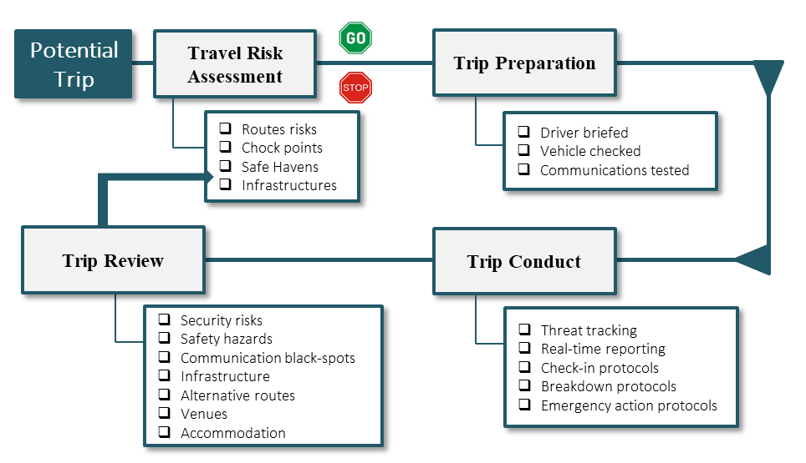

Driver and Vehicle Use Policy
The use of project vehicles must be controlled to ensure only authorized users drive. The driver policy applies to expatriates [long and short-term staff], local managers and staff, partner managers and staff, subcontractor personnel, and client personnel.

Passenger Policy: The use of project vehicles must be controlled to ensure only authorized passengers use these assets.

Seat Belt Policy: The driver and all passengers must wear safety belts at all times while in the vehicle. Staff are responsible for indicating when seat belts or other safety hazards exist to the appropriate manager.

Vehicle Maintenance and Inspection Schedule: Vehicles should be maintained and inspected as a minimum as prescribed in the vehicle manuals and by warranty policies. In the event of an escalation in the Alert State, the SFP is to immediately coordinate the inspection and, if necessary, urgent maintenance, of fleet vehicles.

Minimum Vehicle Equipment: Vehicle should be stocked with a basic tool kit and other essential items, examples include:
- Jack and lug wrench  - Spare tire and locking wheel nut key  - Length of towing cable  - First aid kit | - Vehicle fire-extinguisher  - Jumper cables  - Flashlight and extra batteries  - Water, Oil, Lubricants

 | See the Driver Code of Conduct
 | See the Road Traffic Accident Report Form

Hotel and Residence Selection
The selection and use of hotels or guest houses must be appropriate to staff comfort, but also meet safety and security needs. The Security Manager or Security Focal Point is responsible for evaluating local hotels for any security issues that may cause a problem for visitors and staff. The Security Manager or Security Focal Point will evaluate the hotels for access control, locked side entrances, presence of security cameras, security patrols or checks, security bolts and chains on doors, and good evacuation and emergency plans. The Security Manager or Security Focal Point will ensure the person booking hotels for short-term visitors draw from a list of approved hotels or guest houses, and will update this list on an ongoing basis.
 | Country SSEMP: Travel Risk Management section

Useful Mapping
The Security Manager or Security Focal Point should develop useful mapping to visualize for the team in-country, and as importantly for the headquarters team, the following key points:
- The location of offices and residences.
- Medical infrastructures.
- Diplomatic and useful government locations.
- Hibernation locations and evacuation routes.

Branding
The branding for the activity may be subject to scrutiny from external groups. Branding may include logos, stickers, seals, posters, flyers, stickers on documents [including event brochures], buildings, vehicles or assets. Branding can expose the project and staff to unnecessary risks and so careful consideration should be given to official and unofficial branding. In high-risk environments permission from the donor will be sought on limiting branding to protect the physical welfare of staff. Modifications to the branding approach will be pre-approved through the headquarters team managing the project.

Information Security and Data Back-Ups
Managers and staff should understand that every member of the team is a stakeholder for effective risk management. Each person, regardless of nationality or status, has a role to play to ensure a safe and productive business. However, it is also true that in some environments sharing this Guide and the associated Plan(s) and other details with all staff (internal and external) may be unrealistic, compromise the safety and wellbeing of staff, or expose others to unnecessary risk. As such, restrictions on information sharing may be implemented in alignment with the conditions in each operating area – whether as a matter of routine, or in response to predetermined triggers. The general management guidelines for this project include:
- Do not leave laptops unsecured during working hours.
- Do not leave sensitive information on the desk overnight unsecured.
- Sanitize IT equipment when traveling to higher risk areas.
- A “Clear Desk Policy” and “Locked Office Door” policy will be enforced.
- Keys to offices and the building should not be left unsecured.
- Lost keys and access cards must be reported immediately.
The SSEMT – working with headquarters IT function – will be responsible for protecting IP and SI data through:
- Providing guidance and instructions on data security management for staff and managers, including operational security risk management measures, Acceptable Use Policy guidelines and requirements, lock and key security and clear desk policies, and the mechanism for reporting spillage, loss or information breaches.
- IT will be responsible for ensuring cyber security measures are in place for IT assets and systems.
- Cloud-based data sharing systems will have appropriate security controls in place to safeguard against unauthorized breaches. Email systems will also have appropriate protective measures to prevent access when content is transmitted.

- Donor requirements for the protection of data, and the securing of data transmissions, will be confirmed at the point of contract award.

- All laptops will be password protected and any loss of an IT asset will be reported immediately to IT so that access to cloud-based systems can be denied.

- Laptops will be stored in the boot/truck of vehicles during carriage and will not be left visible within the vehicle and so attract theft.

- Any sensitive data may be carried on an encrypted flash-drive to reduce data loss.

- Lost or copied sensitive data must be reported immediately to the SFP.

- Any portable IT asset and/or printed materials containing sensitive or personal data will be secured within a lockable container, and within a secured room. As required, alarms, CCTVs and IDS may be used to secure the room or area.

 | See the Manager’s Guide to Information Security
 | See the Staff Guide to Information Security
 | See the Acceptable Use Policy Form

Pilfering and Theft
An important aspect of security for a facility is the prevention of pilfering and theft. This includes protecting valuable items and information through lock and key security, as well as creating systems and protocols which reduce the chances of theft. The following methods may be used to control potential theft and pilfering:
- Bags may be searched when entering the facility.
- All persons may be inspected [exception notification can be issued] on entering the facility.
- Spot check searches can be conducted of all staff when driven by events or increased risk.
- All vehicles may be searched when entering the facility or work areas.
- Spot check searches of vehicles may be conducted.
- Internal and compound CCTV cameras can be used to monitor thefts.
- Lockdown procedures may be activated if a theft is reported.
- An appointed manager may search public spaces and offices for stolen items.
Adherence to local laws and sensitivities will need to be a consideration before instigating any measure.

Cash Management
Proper cash management is important for reducing threats to staff and the facility, as well as reducing the chances of pilfering and theft. Managers should consider safety and security precautions such as: [1] should cash should be stored in a safe or lockable cabinet – securely bolted to either a load-bearing, structural wall or concrete floor / joists], [2] Will access to cash be restricted, [3] Will information on cash storage will be restricted, [4] Ensuring information on cash withdrawals and movements is restricted to a limited group, and [5] Varying cash withdrawal schedules to avoid trend setting.
Managers should consider whether security staff should accompany significant cash withdrawals, movements or payments in order to reduce the chances of a robbery and to protect people and the money during transit. This can be especially important where regular cash withdrawals or payments are made for services.
The establishment of cash reserves and the advance payment of staff and vendors may be required ahead of a predicted period of risk or disruption.

Medical Management and Suppliers
It is important for the management team to locate good hospitals and medical centers, as well as professional doctors and dentists for staff to utilize during an emergency. The names and details of medical support services should be recorded and ideally mapping should show where major facilities are located. The Security Manager or Security Focal Point should regularly verify and validate the facilities elected for use through the organization’s medical insurance provider, noting that they would typically maintain a list of assessed facilities.
 | Country SSEMP: Medical Treatment and Emergencies section

Investigations and Discipline
Disciplinary, ethical or criminal investigations are sensitive and should only be conducted with the correct authority from appointed management. No country or staff should conduct investigations without seeking approval from authorized leadership through the management chain – notifying the headquarters leadership team before an investigation commences.
The investigation of thefts, threats or other incidents can be highly sensitive and present safety and security risks for staff and the program as a whole. In addition, inappropriate investigations involving unlawful actions can present legal and reputational risks. The following considerations should be applied before an investigation is conducted:
- Is it legal to conduct an investigation?  - Will it compromise evidence?  - What security implications are there?  - Who might be targeted as a result? | - What are the moral or ethical considerations?  - Who is best placed to conduct the investigation?  - Should the local police be involved?  - What actions will be taken if evidence is found?
Note: The headquarters team must be notified BEFORE an investigation occurs.

Emergency [Crisis] Preparedness and Response
Our team places great value on preparedness, ensuring that as a group we are best prepared to identify, mitigate or deal with a crisis. The ability for management teams to quickly and effectively respond to a crisis in a well-coordinated and pre-determined fashion will significantly affect how well individuals and groups navigate a crisis situation.
- LIMT Structure and Competency: It is important for the management team to define the structure of the team who will actually mobilize to handle the response to any safety or security emergency [the LIMT], as well as its responsibilities, before the crisis occurs. And, the team should define how the LIMT works then with the CMLT for serious incidents.

- Communications and Technologies: The management team should ensure that multiple means of communications are available should an emergency situation occur – at least 3 means should always be available [mobile, landline and Internet]. These should be tested and operational before a crisis occurs.
The use of Risk Calendars and Critical Event Planning measures will allow the SSEMT to identify and plan for upcoming [predictable] threats, whether humanmade or natural, to avoid or mitigate risks. This will also allow the field and headquarters teams to work together – in advance of an event – to control risks.
 | Country SSEMP: Crisis Communications and Stakeholder Management section
 | See the Risk Register and Treatment Plan
 | See the Critical Event Planning Guide
 | See the Emergency Action Plan

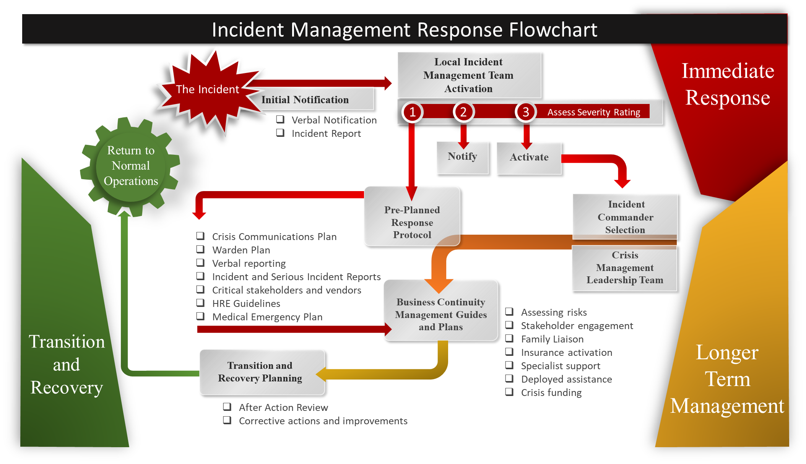
Where an incident occurs the following response process will be used:

Alert States
The following Alert States have been provided to enable emergency and crisis management responses with a more defined structure to deal with a pending emergency event [alert] or an occurring event [incident]. Triggers define response measures to reduce risks or control the impacts of an emergency:
Alert |  | Grading | Reporting | Actions
1 |  | Low / negligible risk levels | Rumors or speculation of possible events | Increased security awareness
2 |  | Low levels of risk | Confirmed reporting of possible minor events | Low-level risk mitigation responses taken
3 |  | Medium levels of risk | Minor events occurring, or reported to occur shortly | Initiate graduated risk and security responses
4 |  | High levels of risk | Significant events are occurring, or about to occur | Initiate security and crisis management protocols
5 |  | Extreme levels of risk | Catastrophic crisis events are occurring or imminent | Initiate full-scale security and crisis response

Trigger Response Plans
It is important for managers to understand how security Alert States might trigger an organizational response. Triggered response protocols ensure that defined and consistent actions are taken when Alert States are issued:
Alert | Political | Social | Security Agency | Hostile Groups
I | Normal political stability within the country and region in general | Social stability is in place with no significant gatherings or public disorder | Government law and order effective with manageable levels of crime and risk | No attacks against similar organizations or foreign groups
II | Tensions within the political arena with possible government instabilities | Public gatherings and minor disorder within parts of the country | Security agencies experiencing difficulties in managing crime and risk factors | Occasional targeting of similar organizations and foreign groups
III | Obvious political tensions with anti-government demonstrations | Inter-ethnic and political group sporadic violence and large-scale gatherings | Security agencies struggling to deal with isolated incidents, or using excessive force | Foreign operations and similar activities targeted frequently
IV | Political offices closed and municipal services suspended. No clear political control | Inter-ethnic and political group violence common – with frequent attacks and large-scale demonstrations | Security agencies unable to contain public disorder and overwhelmed by hostilities. At times complicit in problems | Direct attacks launched against program sites or personnel by hostile groups
V | Loss of political governance with no political leadership in-country | No-social mechanisms in place to contain ethnic cleansing, with looting and murders occurring | Security agencies absent or unable to contain criminal activities. Security agencies complicate in problems | Frequent and targeted attacks against the organization, their personnel and contractors

Threats and Extortion
In many countries threats may be conveyed to coerce or extort an organization or its staff. Threats are often unfounded and turn out to not be real. However, actual threats can result in both physical and psychological harm. This harm would, clearly, relate to the direct victim of the threat or extortion, but, in that the intent of the hostile parties may be to gain access to premises or information, the risk impact can be much wider – with, for instance, sensitive personal information being used to facilitate the terrorist or criminal targeting of individuals, or access to premises enabling the theft of high-value assets and equipment.
If threats are made by known persons [especially if these threats are made publicly] then managers will have some basic information by which to deal with the matter as they will have a greater understanding of the likelihood and potential implications of a threat. If the threat is made by an unknown person or group then it is important to determine the following factors:
- What threats are being made?
- What impacts could they have?
- What is the probability of the threat being carried out?
- Who might be making the threat – can likely perpetrators be short-listed?
- Can phone calls be triangulated by telecommunications service providers?
- Can emails be traced?
- Who answers the phone and can a ruse be used to gather information?
- Is there a trend or pattern to the threat?
- Might the threats be false or made by staff members as a ruse for self-gain?
- What are the safety and security risks?
- Should working and personal practices be changed?
- What training or advice might be required for targeted staff?
- What additional security resources and support might be needed?

Crisis Response Considerations
The ability to quickly and effectively respond to a crisis in a well-coordinated and pre-agreed fashion will significantly affect how well initial and subsequent risks are controlled. This will be accomplished by:
- Crisis Communications: A formal Crisis Communications and Stakeholder Plan must be in place to indicate who is responsible for different functions. The Security Manager or Security Focal Point will ensure it is up-to-date and accurate and has been distributed.
 | Country SSEMP: Crisis Communications and Stakeholder Management section
- Hibernation, Relocation and Evacuation Management: Appropriate staff should be briefed on hibernation, relocation and evacuation plans – the Security Manager or Security Focal Point is responsible for ensuring they are aware of where to find them, and they have access to the instructions they require.
 | Country SSEMP: Hibernation, Relocation and Evacuation section
- Medical Emergencies: Suitable medical facilities or support services should be identified to respond to medical emergencies – the Security Manager or Security Focal Point should ensure these are safe and suitable, and whether services be contracted as needed.
 | Country SSEMP: Medical Treatment and Emergency Management section
- Repatriation [fatalities] Management: A system for the repatriation of deceased remains should be organized – the management team should know how to process a deceased person back to their place of origin.

- Kidnap and Ransom: Staff may receive kidnap and ransom training or advisory information where such threats exist. The SSEMT / LIMT and the headquarters leadership team should understand how to manage a kidnap and ransom situation.

- Fraud, Corruption and Ethical Violations: Staff and managers should understand the dangers associated with fraud and corruption, as well as ethical violations, in terms of individual and group risks – and how to report and manage such an event.

- Extortion and Intimidation: Staff and managers should understand the dangers associated with extortion and intimidation in terms of individual and group risks – and how to report and manage such an event.

- Media Management: Staff and management should be aware of the typical means by which media groups gather information – and how to respond to various forms of media interaction.

- Earthquakes and Floods: Staff and management should be aware of how to respond to localized or widespread earthquake or flood events in terms of immediate response as well as post-incident management.

- Outbreaks of Serious Infectious Disease [Pandemics]: Managers and staff must understand how to prepare for and manage serious infectious disease alerts and events [ranging up to pandemics] in terms of work-from-home policies, social distancing / isolation strategies and hygiene arrangements.

- Stress Trauma Management: Locally based management should understand the signs, symptoms and first responses to stress trauma, for both individuals and groups.

- Should the security situation deteriorate or an emergency event occur, having pre-established triggers and security and safety responses will enable the management team to quickly implement proactive measures to reduce risks before they occur. Managers should plan ahead for potential safety, security and emergency situations and determine best courses of action to meet these possible hazards before they occur. PTSD requirements must be coordinated with the Headquarters leadership team.

- Workplace Violence: Systems and protocols should be in place to deal with work-place violence when operating remotely or in challenged regions where typical support structures are absent.
- Security will be involved with any workplace violence issues.

LIMT Activation Protocol
There are 5 stages within the LIMT activation and response sequence (used in conjunction with the SSEMP documents and working in partnership with the headquarters Crisis Management Leadership Team for serious events).
Stage 1: Notifications
- The initial notification of the event is received from the point of crisis (staff or Security).
- The sender’s details are confirmed and the incident facts are gathered (and confirmed again).
- The LIMT is activated through the Incident Notification System (verbal reporting and SITREPs).
- Other stakeholders (internal and external) are identified and engaged.
Stage 2: Mobilization
- The LIMT is convened, and the Team Leader assumes control.
- The CMLT at the headquarters office are notified for serious incidents (especially level 1 or 2).
- The LIMT members review (refresh) their roles and responsibilities.
- Other locations and deputy Security Managers or Focal Points are notified of the situation.
Stage 3: Respond
- The Team Leader provides the CMLT with ongoing updates, permissions and requests for support.
- The Security (and designates) support the LIMT Team Leader with response protocols.
- The required policies, plans and procedures are identified – the LIMT is refreshed on these.
- Any ‘Just in Time’ training needs are identified for the LIMT.
- The Event Files are started.
- The immediate threats and associated Courses of Action are confirmed and managed.
- The Crisis Communications and Stakeholder Plan is consolidated - stakeholders engaged.
- Immediate support and resource needs are identified and engaged.
- The Emergency Action Plan and pre-prepared responses and other response plans are activated.
Stage 4: Manage
- The threats and associated Courses of Action are monitored and adjusted.
- Support and resources are engaged and managed.
- Information channels and reporting systems are confirmed and implemented.
- A Cost Center is established and funding/financial controls implemented.
- Planning for transition and recovery starts.
- The LIMT Team Leader delegates roles, responsibilities, tasks and timelines.
- The Event Files are maintained by Security and sent to the CMLT Recorder.
- Stakeholder management is implemented: scheduled and event driven briefings are conducted.
Stage 5: Transition
- The End Point is confirmed and any residual tasks captured in a Transition Plan.
- Resources are demobilized once the situation is stabilized.
- All files are consolidated in the Event Dossier.

Note: When the situation stabilizes a written Serious Incident Report [SIR] should be issued. New information to this report should be added in BLUE and old information text changed to black [new is blue] to aid managers in identifying new content during a protracted incident.
 | See the Serious Incident Report Form

Hibernation, Relocation and Evacuation Management
Hibernation, relocation and evacuation management is an important aspect of emergency preparedness. Depending on the nature of the location, activity and prevailing threat conditions, a series of supporting documents may be required to ensure the correct levels of planning are in place for a hibernation or evacuation. While uncommon, the need of individuals [or indeed the entire group] to evacuate from a country may require up to a national level hibernation or evacuation. At this level the headquarters leadership team will be involved in decision making with the country management team.
The Security Manager or Security Focal Point is responsible for identifying triggers which might result in a hibernation, relocation or evacuation situation, for both expatriate and local staff. If warning indicators are triggered then instructions will be issued to managers and staff. Briefings will be held as the situation deteriorates and where the decision to hibernate or evacuate is made, run by the Security where possible, or a pre-designated alternate in the Security Manager or Security Focal Point’s absence.
The headquarters leadership team will be kept informed as to the security or safety situation and possible hibernation, relocation or evacuation needs on a daily basis, or as the situation changes by the Security Manager or Security Focal Point. Scheduled and event-driven calls will be held between the field and headquarters leadership team. The headquarters leadership team will liaise and coordinate international political evacuation insurance measures as needed – notifying the LIMT.
 | Country SSEMP: Hibernation, Relocation and Evacuation section
 | See the Managers Guide to Hibernations, Relocations and Evacuations
 | See the Staff Guide to Hibernations, Relocations and Evacuations

Data Back-Ups and Protection of Assets and Information
During an emergency situation, especially where staff are being evacuated, relocated within the country or operating areas, or are hibernating, specific care must be paid to ensuring critical information and assets are either protected or destroyed / put out of use. For electronic information, data backups may be performed, or hard disks scrubbed and then destroyed by burning. Similarly, hard-copy information may either be collated for transit or secured / destroyed in-situ. The country team will liaise with the headquarters IT department for the protection of data.

Leveraging Resources
Many teams fail to map or exploit available knowledge, resources and capabilities, both in-house and externally. Understanding and documenting possible sources of support will exponentially increase the project’s intelligence and response capabilities. This includes:
- Leveraging internal and external capabilities: Understanding what resources are in-house and can be used to support the project, as well as external agencies and groups.

- Interfacing with other groups: Becoming members of forums, working groups and communities which share information and support.

- Medical and repatriation services: Understanding how to leverage government groups for medical and repatriation services and support.
The Security Manager or Security Focal Point is responsible for gathering all useful program points of contacts and relationships and including these, with remarks, into the Crisis Communications and Stakeholders Plan. This serves as a living repository of “group” knowledge and relationships and should form the basis of a quarterly review by all managers.
 | Country SSEMP: Crisis Communications and Stakeholder Management section

Emergency Cash and Wage Payments
In the event that banking institutions are affected by an emergency situation, or the risk of going to banks to withdraw staff wage and activity or site payments presents a high-risk, then emergency funds may need to be electronically, or physically, transferred to the management team, with staff being pay wages in advance so as to ensure no disruptions to payments occur. The following considerations apply:
- The authority required to request additional bank wires transfers.
- The authority required to make early staff and subcontractor payments.
- The security considerations associated with receiving, moving, storing and distributing cash.
- Safe storage considerations for cash.
- Cash export control issues [for physical movements].
- Information security restrictions regards cash movements and storage.
The management team will work with the headquarters finance department on financial matters and for tracking costs associated specifically with a crisis.

Building Awareness and Competency
Awareness and competency, whether within managers, staff or support staff, operationalizes safety, security and emergency management. It is the responsibility of the SSEMT to ensure that all employees have the opportunity to learn about our safety and security policies and procedures. Additionally, the SSEMT should encourage its staff to ask for learning resources when they feel like they are ill-prepared to face security, safety or emergency issues. The Security Manager or Security Focal Point is responsible for defining learning requirements and objectives on safety and security-related topics.

Training Resources
Training and exercising raises awareness and competency levels across multiple learner groups, while concurrently demonstrating organizational duty of care. Training resources may be provided for multiple learner groups, including: [1] Management, [2] Security Managers and Security Focal Points, [3] International travelers and expatriates, [4] All staff, [5] Vulnerable staff, [6] Drivers, and [7] Guards. Training and exercising may be delivered through: [1] Class-based training, [2] Immersive learning, [3] eLearning, [4] Videogames, and [5] Tabletop or immersive exercising. The following resources are available from at the organizational level:
No | Learner Group | Title | Delivery Mechanism | Provider
1 | Executive Leadership Team | - Crisis Management Team Exercising  - Business Continuity + Crisis Management  - Country Briefing - Pre-Travel Arrival Briefing | - Externally Led exercise  - eLearning Training  - SharePoint | Partners of the Americas
2 | Chief of Party/Project Directors in Country | - Local Incident Management Team Exercising  - Country Briefing - Pre-Travel Arrival Briefing | - Externally Led exercise  - SharePoint | Partners of the Americas
3 | All Staff | - Country Briefing - Pre-Travel Arrival Briefing | - SharePoint | Partners of the Americas
4 | Travelers | - Country Briefing - Pre-Travel Arrival Briefing | - SharePoint | Partners of the Americas

Training Administration
If training is conducted within [or external to] the team it is important that records are kept, and that education is continued to prevent skill fade. The following administrative requirements are required:
- Training Records: Managers should establish a training record system to track all training activities, including the attendee’s name and position, the nature of the training, and when it was conducted.
- Training Report Cards: Training record cards should be kept to track individual and group performance. Ideally, attendees should sign to confirm attendance.
- Periodic Training Reports from Subcontractors: If subcontractors are used then periodic training records should be retained and reports should be submitted for management review.
Training records must be retained as these provide the only mechanism to evidence that staff have been provided risk related information on pertinent topics.

